**EXPERIMENT 5**

1. Consider that X is the time (in minutes) that a person has to wait in order to take a flight.

If each flight takes off each hour X ~ U(0, 60). Find the probability that

1. waiting time is more than 45 minutes, and

Sol.

punif(45, min=0,max=60,lower.tail=FALSE)



1. waiting time lies between 20 and 30 minutes.

Sol.

punif(30, min=0,max=60)-punif(20,min=0,max=60)

2. The time (in hours) required to repair a machine is an exponential distributed random

variable with parameter λ = 1/2.

1. Find the value of density function at x = 3.

Sol.

dexp(3,0.5)

1. Plot the graph of exponential probability distribution for 0 ≤ x ≤ 5.

Sol.

plot(dexp(seq(0,5,0.0001),0.5))

1. Find the probability that a repair time takes at most 3 hours.

Sol.

pexp(3,0.5)

1. Plot the graph of cumulative exponential probabilities for 0 ≤ x ≤ 5.

Sol.

plot(pexp(seq(0,5,0.0001),0.5))

(e) Simulate 1000 exponential distributed random numbers with λ = 1⁄2 and plot the

simulated data.

Sol.

y <- rexp(1000,0.5)

y

plot(density(y))

hist(y)

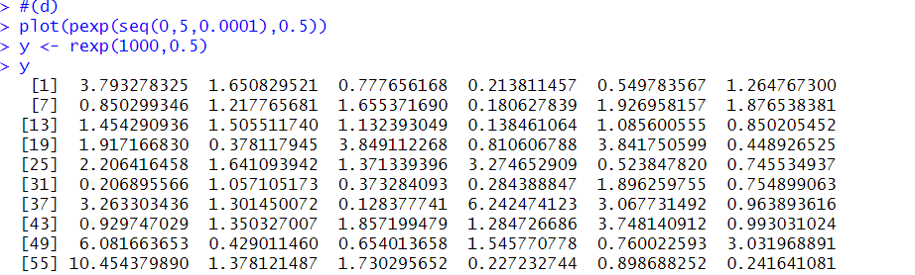

3. The lifetime of certain equipment is described by a random variable X that follows

Gamma distribution with parameters α = 2 and β = 1/3.

1. Find the probability that the lifetime of equipment is at least 1 unit of time.

Sol.

pgamma(1,shape=2,scale=1/3,lower.tail = FALSE)



1. What is the value of c, if P(X ≤ c) ≥ 0.70? (Hint: try quantile function qgamma())

Sol.

qgamma(0.7,shape=2,scale=1/3)

**EXPERIMENT 6**

(1) The joint probability density of two random variables X and Y is

Then write a R-code to

1. check that it is a joint density function or not? (Use integral2())

Sol.

install.packages('pracma')

library('pracma')

f<-function(x,y){

return (2*(2*x+3*y)/5)

}

i<-integral2(f,xmin=0,xmax=1,ymin=0,ymax=1)

i$Q

1. find marginal distribution g(x) at x = 1.

Sol.

g<-function(y){

return (f(1,y))

}

i=integral(g,0,1)

i

1. find the marginal distribution h(y) at y = 0.

Sol.

h<-function(x){

f(x,0)

}

integral(h,0,1)

1. find the expected value of g(x, y) = xy.

Sol.

m<-function(x,y){

return( x*y*(2*(2*x+3*y))/5)

}

j=integral2(m,xmin=0,xmax=1,ymin=0,ymax=1)

j$Q

(2) The joint probability mass function of two random variables X and Y is

Then write a R-code to

1. display the joint mass function in rectangular (matrix) form.

Sol.

f<-function(x,y){

(x+y)/30

}

x<-c(0:3)

y<-c(0:2)

mat<-matrix(c(f(0,0:2),f(1,0:2),f(2,0:2),f(3,0:2)),nrow=4,ncol=3,byrow=TRUE)

print(mat)

1. check that it is joint mass function or not? (use: Sum())

Sol.

if(sum(mat)==1){

paste("It is joint mass fxn")

}else{

paste("not jms")

}

1. find the marginal distribution g(x) for x = 0, 1, 2, 3. (Use:apply())

Sol.

g<-apply(mat,1,sum)

g

1. find the marginal distribution h(y) for y = 0, 1, 2. (Use:apply())

Sol.

h<-apply(mat,2,sum)

h

1. find the conditional probability at x = 0 given y = 1.

Sol.

mat[1,2]/h[2]

1. find E(x), E(y), E(xy), V ar(x), V ar(y), Cov(x, y) and its correlation coefficient.

Sol.

ex<-sum(x*g)

ex

ey<-sum(y*h)

ey

f2<-function(x,y){

x*y*(x+y)/30

}

mat2<-matrix(c(f2(0,0:2),f2(1,0:2),f2(2,0:2),f2(3,0:2)),nrow=4,ncol=3,byrow=TRUE)

exy<-sum(mat2)

exy

ex2<-sum(x*x*g)

var_x=(ex2-ex*ex)

var_x

ey2<-sum(y*y*h)

var_y=ey2-ey*ey

var_y

cov<-exy-ex*ey

cov

corr<-cov/(sqrt(var_x*var_y))

corr

**EXPERIMENT 7**

1. Use the rt(n, df) function in r to investigate the t-distribution for n = 100 and df = n − 1 and plot the histogram for the same.

Sol.

n<-100

df<-n-1

x<-rt(n,df)

x

hist(x)

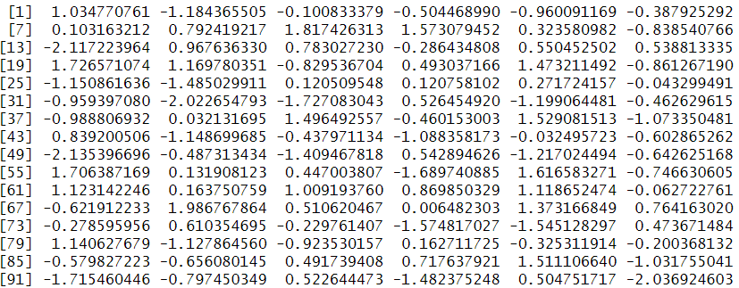

1. Use the rchisq(n, df) function in r to investigate the chi-square distribution with n = 100 and df = 2, 10, 25.

Sol.

rchisq(n,2)

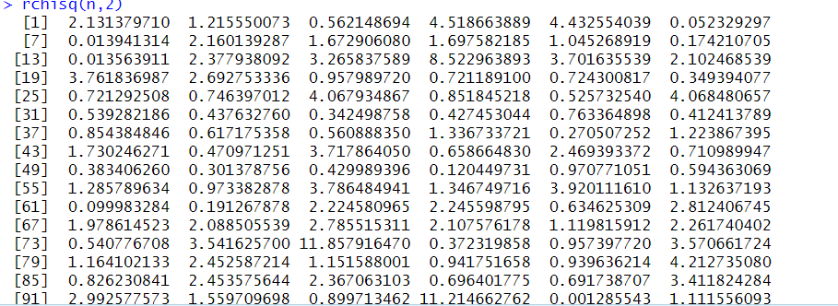

rchisq(n,10)

rchisq(n,25)

(3) Generate a vector of 100 values between -6 and 6. Use the dt() function in r to find the values of at-distribution given a random variable x and degrees of freedom 1,4,10,30. Using these values plot the density function for students t-distribution with degrees of freedom 30. Also shows a comparison of probability density functions having different degrees of freedom (1,4,10,30).

Sol.

x<-seq(-6,6,length=100)

df1=dt(x,1)

df2=dt(x,4)

df3=dt(x,10)

df4=dt(x,30)

df1

df2

df3

df4

plot(x,df4)

color=c("red","green","yellow","blue")

df<-c(1,4,10,30)

for (i in 1:4) {

lines(x,dt(x,df[i]),col=color[i])

}

(4) Write a r-code

(i) To find the 95th percentile of the F-distribution with (10, 20) degrees of freedom.

Sol.

x<-0.95

qf(x,10,20)

(ii) To calculate the area under the curve for the interval [0, 1.5] and the interval [1.5, +∞) of

a F-curve with v1 = 10 and v2 = 20 (USE pf()).

Sol.

x<-1.5

df1<-10

df2<-20

pf(x,df1,df2)

pf(x,df1,df2,lower.tail = FALSE)

(iii) To calculate the quantile for a given area (= probability) under the curve for a F-curve

with v1 = 10 and v2 = 20 that corresponds to q = 0.25, 0.5, 0.75 and 0.999. (use the qf())

Sol.

v1<-10

v2<-20

qf(0.25,v1,v2)

qf(0.5,v1,v2)

qf(0.75,v1,v2)

qf(0.999,v1,v2)

(iv) To generate 1000 random values from the F-distribution with v1 = 10 and v2 = 20 (use

rf())and plot a histogram.

Sol.

y<-rf(1000,v1,v2)

hist(y)

**EXPERIMENT 8**

A pipe manufacturing organization produces different kinds of pipes. We are given

the monthly data of the wall thickness of certain types of pipes (data is available on

LMS Clt-data.csv).

The organization has an analysis to perform and one of the basic assumption of that

analysis is that the data should be normally distributed.

You have the following tasks to do:

1. Import the csv data file in R.

Sol.

df<-read.csv("C:/Users/ExtremePc/Downloads/Clt-data.csv")



(b) Validate data for correctness by counting number of rows and viewing the top

ten rows of the dataset.

Sol.

nrow(df)

head(df,10)

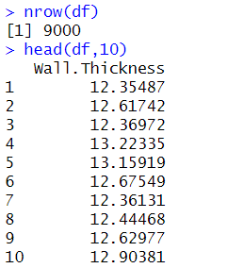

1. Calculate the population mean and plot the observations by making a histogram.

Sol.

m<-mean(df$Wall.Thickness)

m

hist(df$Wall.Thickness)

1. Mark the mean computed in last step by using the function abline.

Sol.

See the red vertical line in the histogram? That’s the population mean. Comment on

whether the data is normally distributed or not?

Now perform the following tasks:

(a) Draw sufficient samples of size 10, calculate their means, and plot them in R

by making histogram. Do you get a normal distribution.

s<-sample(df$Wall.Thickness,10)

s

mean(s)

hist(s)

v<-c()

for (i in 1:9000) {

v[i]=mean(sample(df$Wall.Thickness,10),replace=TRUE)

}

v

hist(v)

abline(v=m,col="red")

(b) Now repeat the same with sample size 50, 500 and 9000. Can you comment on

what you observe.

Here, we get a good bell-shaped curve and the sampling distribution approaches

normal distribution as the sample sizes increase. Therefore, we can recommend the

organization to use sampling distributions of mean for further analysis.

s1<-sample(df$Wall.Thickness,50)

m1<-mean(s1)

v<-c()

for (i in 1:9000) {

v[i]=mean(sample(df$Wall.Thickness,50),replace=TRUE)

}

v

hist(v)

#similarly with 500 9000 sample sizes

s2<-sample(df$Wall.Thickness,500)

m2<-mean(s2)

s3<-sample(df$Wall.Thickness,9000)

m3<-mean(s3)

s4<-c(m1,m2,m3)

s4

